9.1 Two identical, non-interacting spin-1/2 particles of mass m are in the one-dimensional harmonic oscillator for which the Hamiltonian is
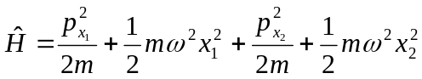
a) Determine the ground state and first excited state kets and corresponding energies when the two particles are in a total spin-0 state. What are the lowest energy states and corresponding kets for the particles if they are in a total spin-1 state?
b) Suppose the two particles interact with a potential energy of interaction
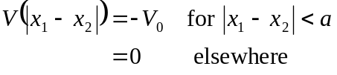
Will the energies of part a) be raised or lowered as a result of 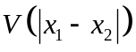?
Solution:
a) The Hamiltonian is the sum of two parts, one containing only x₁ and the other x₂ where 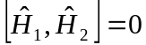. Therefore, we can label the eigenstates by 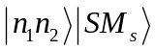 where 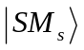 is the two-particle total spin state. The energy is given by 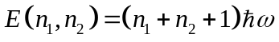.
The ground state energy corresponds to 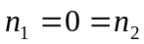 so that the ground state energy is 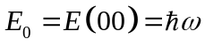. The ket corresponding to the ground state is 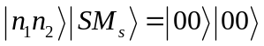.
The first excited state energy is 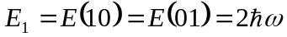with 4 possible kets:
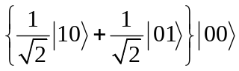 (singlet) and 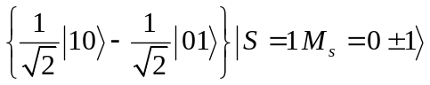 (triplet)
b) ) For the interaction potential given, the energy is lowest when the two are close together, i.e. closer than a. Therefore, the states for which the particles come closest will have the lowest energy. The particles come closest when they have anti-symmetric spin states, i.e. the ground state. Therefore, the total spin-0 state will have the energy lowered more than that of the total spin-1 state.

9.2 Make an order-of-magnitude estimate of the the singlet-triplet splitting of the energy levels of helium due to a direct spin-spin interaction of the electrons by comparing with the magnitude of the hyperfine interaction in hydrogen. By comparing this estimate with the observed splitting, 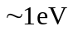, what conclusions can be drawn about the relative effects of exchange symmetry and spin-spin interaction on the energy?
Solution:
Since the average separation between the two electrons in the helium atom is comparable with that between the electron and proton in hydrogen, the size of the spin-spin interaction can be inferred from the size of the hyperfine interaction in hydrogen. We must, however, replace the magnetic moment of the proton with that of the electron. The magnetic moment of the electron is greater than that of the proton by roughly the ratio of the masses 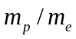. Therefore, the spin-spin interaction should be roughly 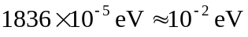 which is much smaller than the ~1 eV energy splittings that are observed. We conclude that the exchange symmetry of the spatial wave functions is largely responsible for the splitting.
9.3 A helium atom is excited from the ground state to the autoionizing state 2s4p by absorption of ultraviolet light. Assume that the 2s electron moves in the unscreened Coulomb field of the nucleus and the 4p electron in the fully screened Coulomb potential
a) Obtain the energy of this autoionizing level and the corresponding wavelength of the ultraviolet light required to effect this excitation. Make an energy level diagram showing this level together with the ground states of neutral, singly ionized and doubly ionized helium atoms.
b) Find the velocity of the electron emitted in the autoionizing process in which the 2s4p state decays into a free electron and a He⁺ ion in the ground state.
Solution:
a) 2s is unscreened. Therefore, (in atomic units) 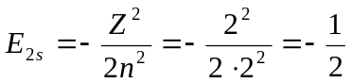. Since the 4p is fully screened the effective nuclear charge is 1 and 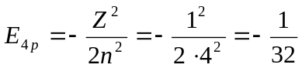. Therefore,
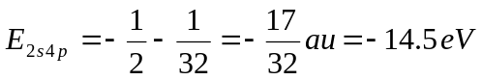. Graphically, we have
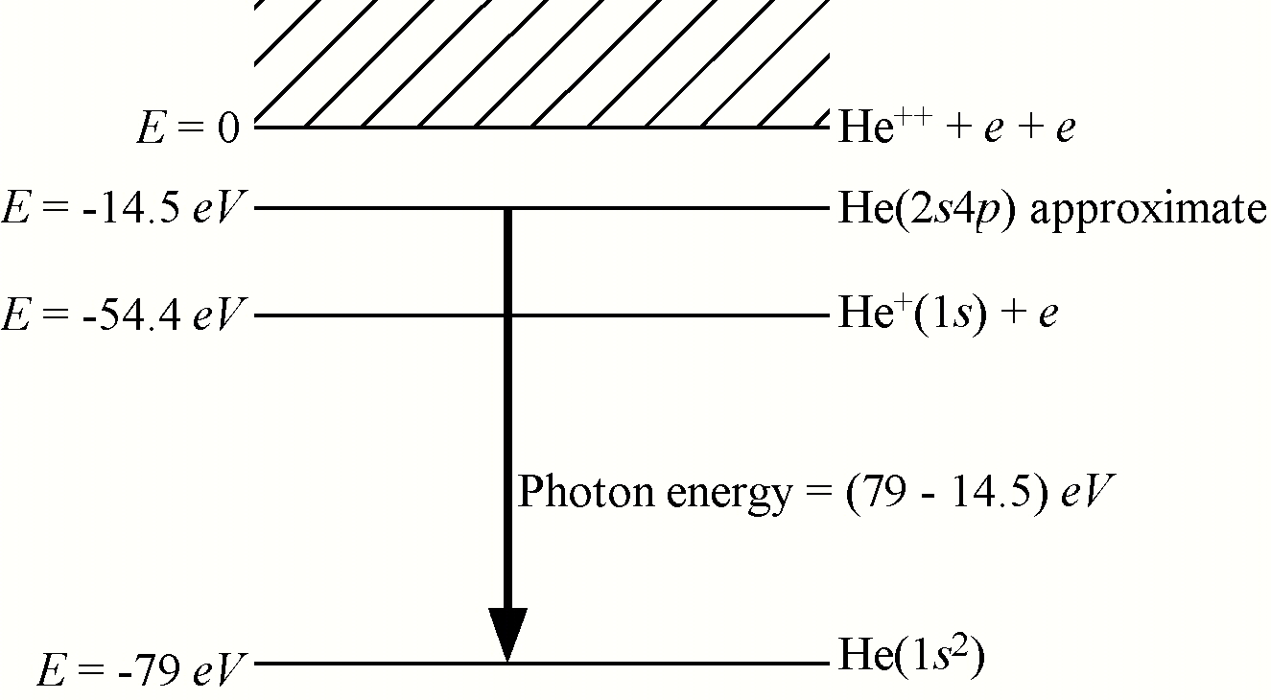

Since the photon energy is 64.5 eV, the wavelength is 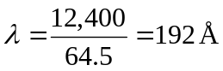
b) The electron kinetic energy is the difference between the autoionizing level and He⁺(1s):
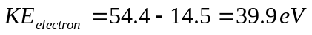 so 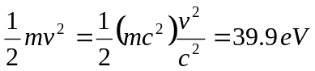. Therefore,
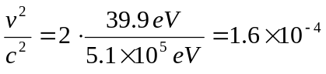 so 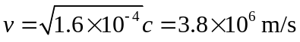

9.4 Use the variational principle to calculate the ground state energy of a hydrogen atom (in atomic units) using the normalized trial functions:
a) 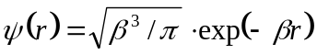 and b) 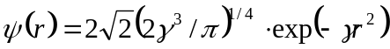 where β and γ are parameters.
c) Which gives the most accurate answer? Why?
Solution:
a) 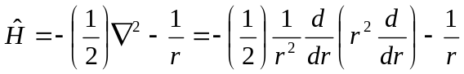 and
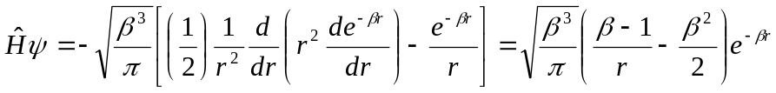. Therefore,
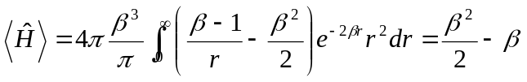. Now, minimizing wrt β, we have
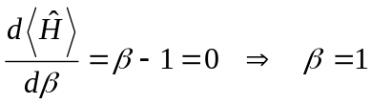 which gives, as we should have expected, the exact grounds state wave function. The energy is therefore, 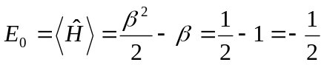 which is the exact ground state energy.
b) The Hamiltonian is exactly the same as for part a). Differentiation and integration using the given wavefunction yields 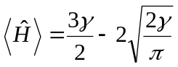. Minimizing wrt γ gives
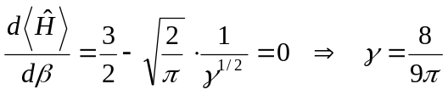and
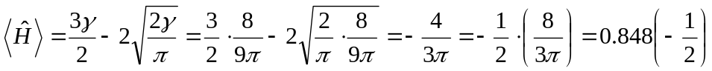
so that using this wavefunction gives a ~15% error.
c) Of course a) gives the most accurate answer because the minimization process produced the exact ground state wavefunction.

9.5 A negative ion is formed when an electron attaches to an atom (or molecule), the result being that the nucleus of charge Z binds 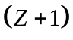 electrons. The binding energy of the electron to the neutral atom is referred to as the electron affinity of the atom. The electron affinity may also be thought of as the ionization potential of the negative ion. Not surprisingly, the halogen atoms form negative ions most readily. This means that the halogen atoms have the highest electron affinities of all atoms (~3 eV). Hydrogen atoms also form negative ions. The electron affinity of hydrogen is 0.75 eV. Use perturbation theory as it was applied to the helium atom to determine the total energy of the hydrogen atom negative ion. Compare the answer with the actual value. Compare the accuracy of the perturbation theory results for the hydrogen negative ion with the result for the helium atom. Why is perturbation theory more accurate for helium? Note that there are no "new" calculations necessary.
Solution:
Everything is the same as for helium except that 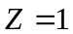. Thus, the unperturbed energy is merely twice the ground state energy of hydrogen, that is 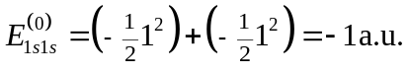 The integral
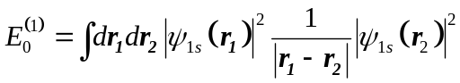 has already been calculated for an arbitrary value of Z.
It is 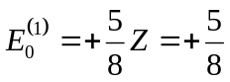. Therefore, the total energy of the hydrogen negative ion, as given by perturbation theory is 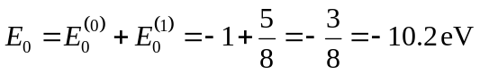. (This is unrelated to the separation between the ground and first excited state of neutral hydrogen being 10.2 eV.)
The experimentally determined total energy is 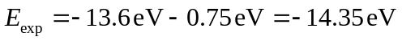so the error is considerable, especially compared with that for helium. Evidently the reason is that the perturbation term, the e-e repulsion, is a larger fraction of the unperturbed energy in hydrogen than it is in helium.
That is, for hydrogen 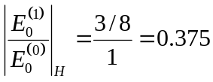, while for helium 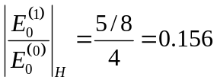.

9.6 Assume the normalized trial wave function 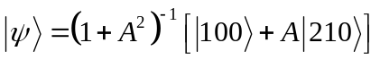, where the kets on the right hand side are spherical hydrogen atom eigenkets, represents a ground state hydrogen atom in a constant electric field F. This wave function represents a state that has "ground state character" and, assuming 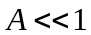, a small amount of 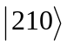 character.
a) Using this trial wave function show that, if terms in 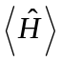 having powers greater than 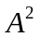 can be neglected, then second order perturbation theory, as applied in Chapter 9, yields the same energy as the variational treatment. Note that if powers of A greater than two can be neglected in that powers of A greater than one may be neglected in 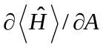.
b) Using this trial wave function estimate the dipole polarizability of ground state hydrogen and compare the answer with the exact answer given in Chapter 9.
Solution:
a) We must first normalize 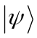 by finding K.
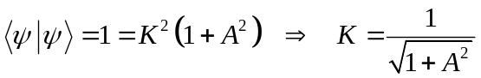
The Hamiltonian is 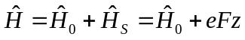 as in Chapter 9.
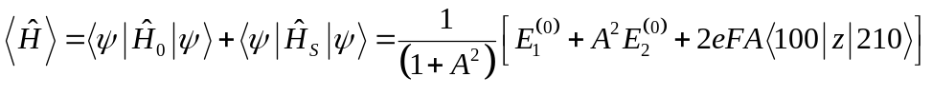
Now minimize w.r.t A.
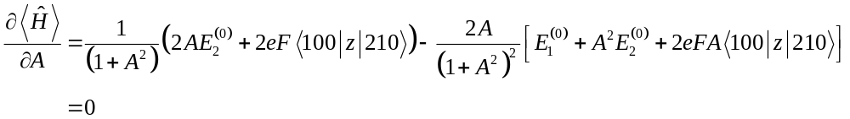
so
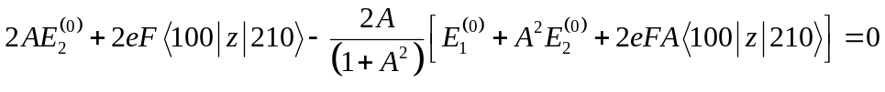
Retain only terms to the first power in A since . We have
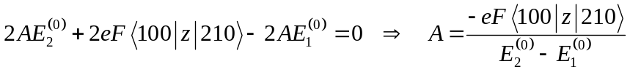
Returning to , we may re-write it in terms of our approximation that . Since we are in rather than its derivative we keep terms in .
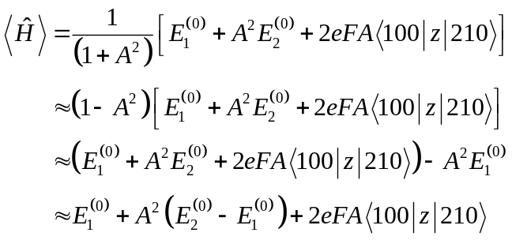
Substituting for A we get
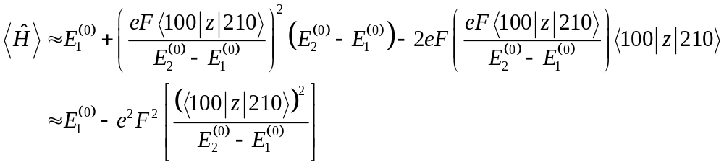
Notice that this is precisely the same expression that would be obtained using second order perturbation theory with the assumption that the only unperturbed state that contributes is 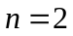.
b) To find the polarizability we recall that 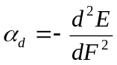 so we require the coefficient of 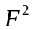. That is, the energy of the ground state hydrogen atom in the electric field will be
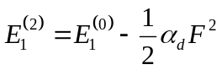 where 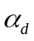 is the diple polarizability. (Recall that 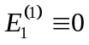) Therefore, we must compute the integral 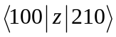.

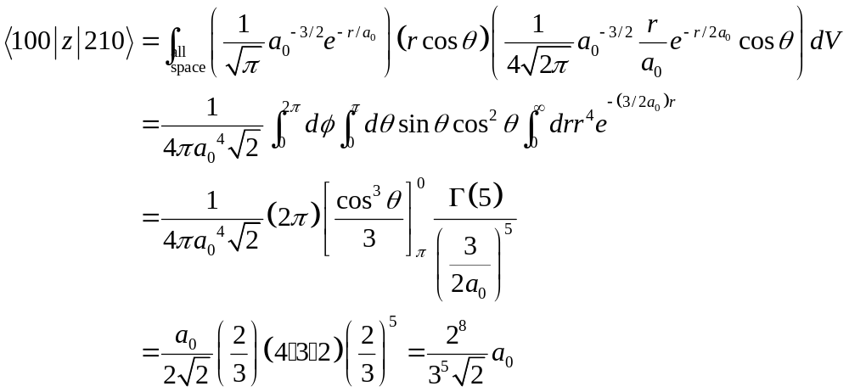

Then, the energy resulting from application of the electric field is
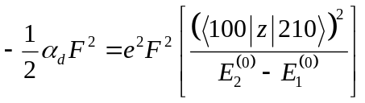
so
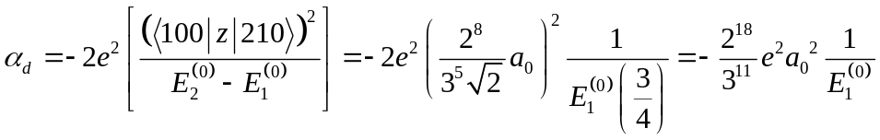
From Chapter 1, the energy may be written as 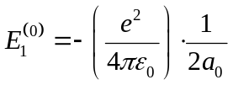so finally we have

This may be compared with the exact answer 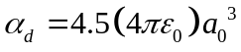. Since we see that the energy obtained using the variational method is indeed highet than the actual energy.

